Rodger Heidgerken
Professor Johnson
ENVS2004
Spring 2020

Title:
Mapping Development and Predicting the Future in Bowdoinham, Maine: A Temporal Analysis of Development and Subsequent Predictions for the Future

Developed by Rodger Heidgerken and the Town of Bowdoinham

Background Information:
According to the comprehensive plan of Bowdoinham, Maine, as of 2011, 56% of Bowdoinham was covered by trees and only 1.7% of land in Bowdoinham was developed (Bowdoinham 2014). Trends in development between 2001 and 2011 were steady, and most developments within Bowdoinham consisted of five single-family detached residential dwelling subdivisions; the number of new houses was not recorded (Bowdoinham 2014). Additional development between these years includes the building of two institutional structures and one commercial structure (Bowdoinham 2014). For these new subdivisions, 25% of subdivision land is required to remain “open space” (Bowdoinham 2014). There are additional regulations put on new development that can be found in articles 4, 7, 8, 9, and 10 of the Bowdoinham’s land-use ordinates (Bowdoinham 2014). Within Bowdoinham, development with minimal impact is allowed to occur without a permit (Bowdoinham 2014). At the time of analysis in 2011, the projected number of housing units was expected to climb to 1,393 units in 2024 (Bowdoinham 2014). This projection implies that, given current laws on lot size and building density in Bowdoinham, 114 acres of land would be required for the development (Bowdoinham 2014). Additionally, if development were to occur through new subdivisions, they estimate that up to 17 acres of road and other infrastructure would be needed. (Bowdoinham 2014)
Bowdoinham’s development plan focuses on fostering small scale growth in the housing sector and from-home business. They have been successful in meeting their goal by constructing sidewalks in the village district, adding public Wi-Fi to town-owned properties, and winning a ConnectME grant to improve broadband connectivity within Bowdoinham. Now, as we get closer to the tenth anniversary of Bowdoinham's 2014 Comprehensive Plan, what have we seen in terms of development over the past years, and what do we expect beyond 2024? By producing maps that represent development since 2000 – showing parcels where new tax accounts have opened as well as where new tax zones have appeared – I will be able to plot new development in Bowdoinham and spatially project development trends to predict new growth in the future. Further, I have developed a model that applies ranked parameters to areas of importance in Bowdoinham such as land surrounding schools, public lands, major roads, places of worship, town facilities, and areas with quality soil. This model will help us identify “hot spots” where we may expect future development to occur. The goal of this analysis is to aid the Select Board, Town Manager, and Town Planner in the development of an updated comprehensive plan in the 2020s including an updated "build out analysis". The ultimate goal of this project would be to inform decisions on town legislation regarding controls on development in Bowdoinham. I first define our research question, present our methods and data, and then look at trends in development over the past 20 years from 2000-2019. I move on to present a model that depicts "hot spot" projections in Bowdoinham, areas where we may expect future development. I discuss the accuracy of our model’s projections, and then I discuss the implications of the findings.

Research Question:
Given data detailing the development of new properties, tax accounts, and the formation of new subdivisions in Bowdoinham over the past 10 years from 2010-2019, can we map development through the opening of new tax accounts, subdivisions, and split-lots? Based upon this analysis, can we define parameters to areas of social importance (parcels within the proximity of roads, town buildings, public lands, places of worship, schools, farmland) to predict what areas of Bowdoinham we expect to see development in the next 10 years. What may this mean for future regulations in Bowdoinham?

Data and Methods:
This analysis spans the Town of Bowdoinham, Maine, located in Sagadahoc county along Merrymeeting Bay. A reference map with the location of Bowdoinham within Maine can be seen below.
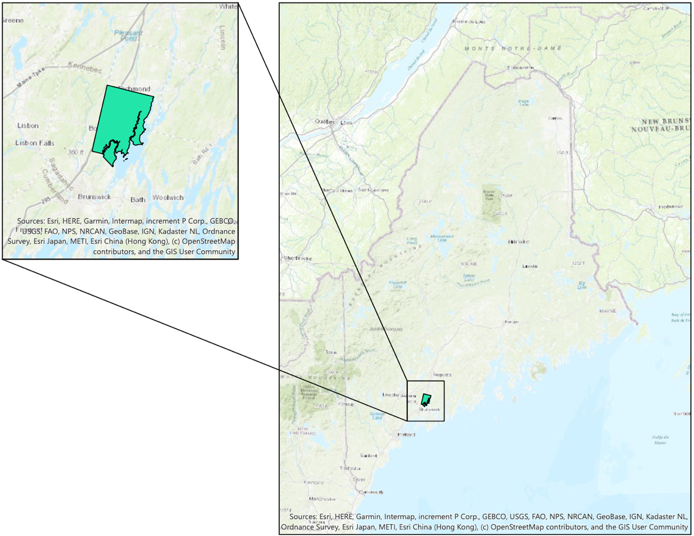
Fig 1: Maps showing the location of the Town of Bowdoinham, the study space, in reference to the State of Maine. The Town of Bowdoinham is in green on both maps.

Data for this project comes from multiple sources listed in the table below:
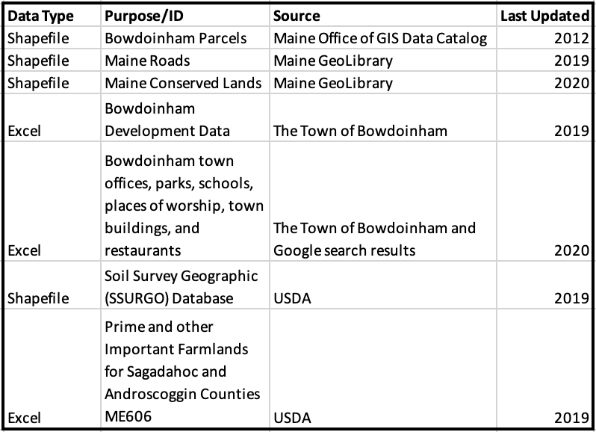
Table 1: Data sources for this project.
I have chosen three prior GIS analyses to help me develop my methodology. First, Linder G. Ringo (2009) converts address data into lat-long data and uses both vector and raster data to create a raster layer of ranked importance. This paper is important to me because it shows how I could go about ranking areas of importance using raster calculations. I followed this methodology, but instead of converting all vector/polygon data to raster, I parameterized vector data layers using rank fields. The second main source, Danesh, et al (2019), uses elements of what they call a “weighted linear combination method”, or a method of weighing data layers either using vector or raster analysis. This general method informed me of how I could linearly develop my ranked model. The third source, Fagir (2016), uses a more modern version of ArcGIS than Ringo’s paper, but it provides insight into the same sort of weighted sight selection. This paper helped me contextualize Ringo’s paper in a more modern spatial question setting.
To create maps that depict past development within the Town of Bowdoinham, I collected data provided by The Town of Bowdoinham on home and business development including the year in which the development occurred using Microsoft Excel. This data was then imported to ArcGISPro in CSV format. I also use the most recent shapefile parcel data from the Town of Bowdoinham. Both of these data sets have Map-Lot data entries with which I can join development data and map it onto parcel blocks using the add-join function of ArcGISPro. Selecting by attribute, I mapped development for four 5-year blocks starting in the year 2000: 200-2004, 2005-2009, 2010-2014, and 2015-2019. I created unique layers for each 5-year block of development by selecting parcels for which the “year built” data was not null, and I then used the create a layer from the selection tool to create a new shapefile from the parcel shapefile. Upon further inspection, I found that not all development from 2000-2019 mapped onto Bowdoinham’s parcel shapefile. This issue is not from the join function within ArcGISPro, but rather it is an issue with the parcel shapefile data as it was not fully up to date. I estimated the error in depiction to affect around 10 parcels, or around 3.68% of the total parcels within our dataset (10/272). While this error in data depiction does not affect the maps produced in a significant way, all data analysis was done in Microsoft Excel to ensure that no entries went uncounted.
An important part of this analysis is to categorize development by type: subdivision, lot-split, and undefined. The information within the MAP-LOT data column from the Town of Bowdoinham tells us whether the development comes from a Subdivision (including two "-" and ending in three numbers) or a lot split (including two "-" and ending in a letter such as RO6-044-A). To identify data entries with these specific attributes, I created two unique CSV files that represent only the parcels that had been developed via subdivision or lot-split. To map these CSV files, I imported them into ArcGISPro, and I used the addjoin function once again basing the join off of Map-Lot data. Using the same method as above, I created shapefiles from selected parcels where the “year built” entry was not null. I did not do the same for parcels with undefined development types. I placed the subdivision and lot-split shapefiles above the total development shapefile in the final map packages. This gives us a map that spatially represents the type of development we see in Bowdoinham over the past 20 years.
In addition to mapping past development within the Town of Bowdoinham, I developed a model to predict future development within Bowdoinham. This model defines parameters to four measures of “attractiveness” for development: proximity to public roads, proximity to public lands, proximity to points of interest, and presence of quality farmland. The model uses proximity to these parameters to symbolize “hot spots” where we may expect development within the foreseeable future.
I first collected shapefiles on roads within Bowdoinham from the Maine GeoLibrary and public lands also from the Maine GeoLibrary. I then collected data on schools within Bowdoinham from public records, places of worship within Bowdoinham from public records, and Bowdoinham town facilities from public records. Data on schools, town buildings, public places, and other notable places within Bowdoinham were classified as Points of Interest (POI) and aggregated into one Excel spreadsheet. The development data that the Town of Bowdoinham provided me with included all recorded data on all parcels within Bowdoinham since recording began; I used the public address data of the POIs, and I matched them with Map-Lot data using the VLOOKUP function within Excel. This allowed me to export POI data as a CSV file into ArcGISPro. Using the same methods as mapping past development, I joined the POI data with the parcel shapefile data by “Map-Lot”, selected parcels where the “year built” entry was not null, and I created a unique shapefile from the selected parcels. For the public land shapefile, I clipped the file to the Bowdoinham parcel shapefile. For the roads shapefile, I selected roads where the town/city data was equal to Bowdoinham and created a unique layer from the selected attributes. Finally, I imported a shapefile to ArcGISPro from the most recent (Created in 2003 but updated in 2019) USDA agricultural land survey for Sagadahoc County. I clipped this data to the Bowdoinham parcel shapefile, and I selected data entries where the soil type was equal to defined quality farmland types from the Soil Data Access (SDA) Prime and other Important Farmlands database for the district ME606 (Androscoggin and Sagadahoc Counties). I created a new layer from the selection that only depicts quality farmlands within Bowdoinham.
The model takes into consideration the proximity of parcels to public land and public roads. To define proximity for the road, public land, and POI shapefiles, I selected parcels from the original parcel layer by location around these three variables. The distances from the points of interest, public lands, and roads can be seen in the table below:

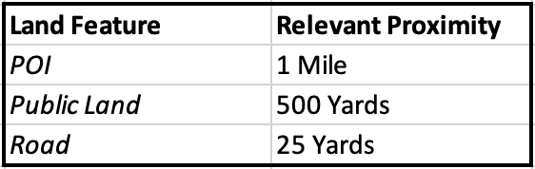
Table 2: Shows the distance of relevant proximity for parcels around points of interest, public lands, and public roads.

The relevant proximity from points of interest was decided on how well the selected parcels represent the two Village districts of Bowdoinham. The relevant proximity to public land was decided based on the definition of walkability (approximately 0.25-0.3 miles). The relevant proximity to public roads was based on common right of way distances and the ease of constructing a driveway assuming average dimensions (4 yards by X yards) where X is the length of the driveway up to 25 Yards priced by $5.50/ft^2 (Less than $5,000). Rounding each of these numbers to 1 Mile, 500 Yards, and 25 Yards made the analysis much easier to conduct. I created three new shapefiles from the selected parcels within the proximity to the above variables: these are POIProx1M, PublicLandProx500Y, and RoadProx25Y.
To add parameters to the shapefiles representing proximity to the four measures of attractiveness for development, I built a model within ArcGISPro. This model can be seen below:
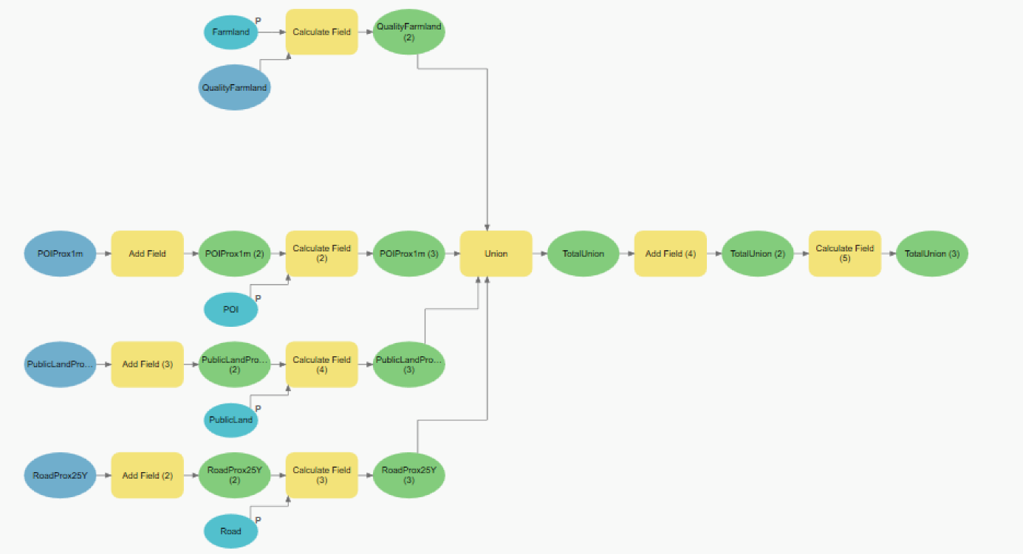
Fig 2: Model defining parameters to measures of attractiveness for development within Bowdoinham, Maine. Farmland represents the shapefile for quality farmland. POIProx1m represents parcels within 1 mile from points of interest, PublicLandProx500Y represents parcels within 500 yards from public land, and RoadProx25Y represents parcels within 25 yards from a public road.

The model works by adding fields to the POIProx, PublicLandProx, and RoadProx layers that gives them a place to add a ranking. Because of the prior layer manipulation, the farmland shapefile had already had a ranking field added. The model then calculates the new rank field to be equal to any arbitrary number defined by the user. It then uses the union tool to combine all the shapefile information into one shapefile called “TotalUnion”. A totalrank field is then added to the TotalUnion that is calculated by aggregating the parameters defined to each rank field from the four attributes (SoilRank, POIRank, PLRank, and RoadRank). This model creates a shapefile called “TotalUnion”, and this layer is symbolized based on the totalrank field; the final product is a layer that depicts on a color gradient how likely we are to see development in Bowdoinham for the foreseeable future. Using parameters, I developed a tool that can be used to modify the analysis in the future. The reason behind the parameter values I chose, however, is that I wanted to create a model that not only represents future development potential, but that could also explain past development trends. Using the parameters below, only two out of 272 developed parcels (0.74%) fall within areas where 0 future development was expected:

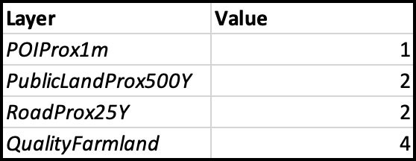
Table 3: Shows the parameters given to each individual attribute of the TotalUnion totalrank field. Because Bowdoinham is such a small town with few defined points of interest, applying a parameter of greater than 1 to POIProx1m did not seem appropriate because it would not represent development trends throughout the whole town. Having said this, over 1/3 of all parcels in Bowdoinham are within a mile of a defined POI.

From this process, I have developed four maps representing development in 5-year blocks, one map to represent all development from 2000-2019, one map showing development since 2000 in terms of subdivision, lot split, or undefined, and one map that predicts where we may expect to see development in the future. From these maps, areas of significant development in Bowdoinham over the past 20 years will be identified and compared with areas where we may expect significant development in the future. I will then comment on the questions that the model provokes in terms of future development laws in Bowdoinham.
All maps representing the progression of development in Bowdoinham, the type of development in Bowdoinham, and the predictions on future development in Bowdoinham, as well as the future development model, will be delivered to the Town of Bowdoinham to aid in their next Comprehensive Plan.

Results:
The next set of maps show development in the Town of Bowdoinham from 2000 until 2019 by 5-year blocks.

2000-2004:
The majority of the recorded development in Bowdoinham from the year 2000 to 2019 occurs in between 2000 and 2004 at 137 parcels. There is almost an even mix of development that takes place between the two Village Districts and the Residential/Agricultural District. Development during these years often occurs in blocks of two or more parcels such as the ones you can see just off of River Rd. in North-Eastern Bowdoinham.

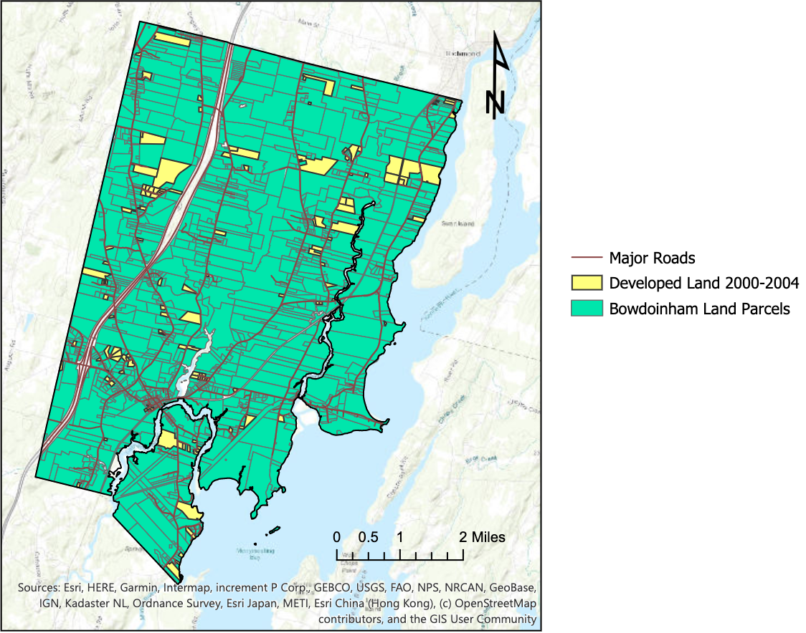
Fig 3: This map shows development in Bowdoinham from the years 2000-2004. As the legend suggests, major roads are highlighted in a dark brown, developed land is in yellow, and other parcels are in green.
2005-2009:
Trends in development from 2005-2009 are similar to the trends in development from 2000-2004. There were, however, fewer parcels developed in this timeframe at 60, and the majority of these parcels exist in the Residential/Agricultural District as opposed to the two Village Districts. Notable development occurred on Post Road and Carding Machine Road.

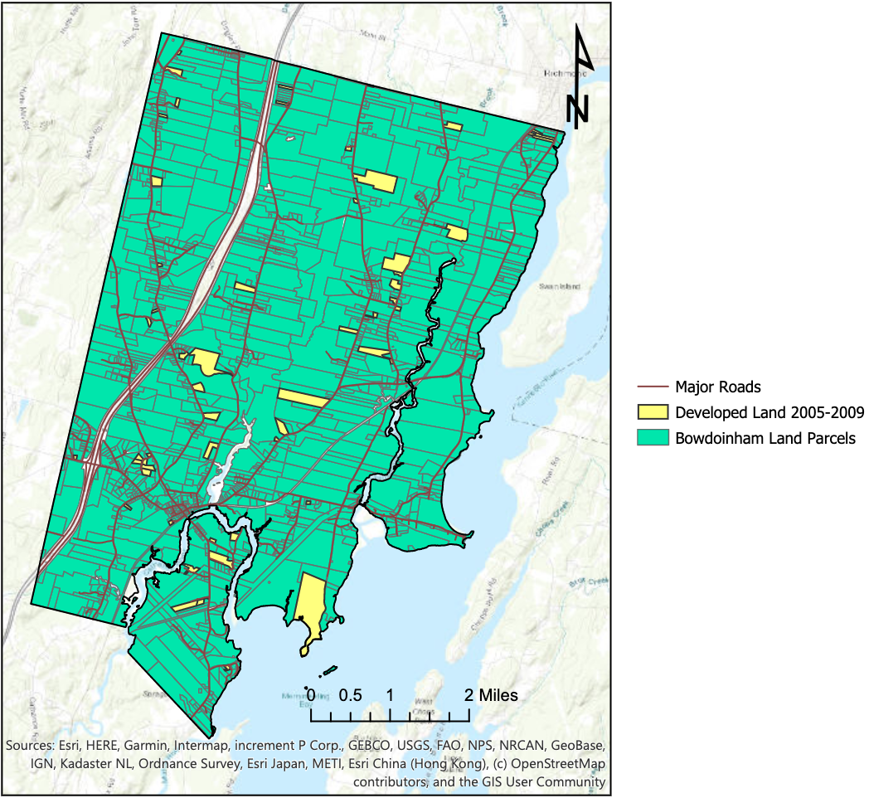
Fig 4: This map shows development in Bowdoinham from the years 2005-2009. As the legend suggests, major roads are highlighted in a dark brown, developed land is in yellow, and other parcels are in green.

2010-2015
According to town records, only 35 parcels were developed from 2010 to 2014. This is a significant decrease from the past 10 years. The development we saw during these years also seems to have taken up a smaller aggregate area than the prior two 5-year blocks from 2000 onward. The development in this period is mostly confined to the two Village Districts.
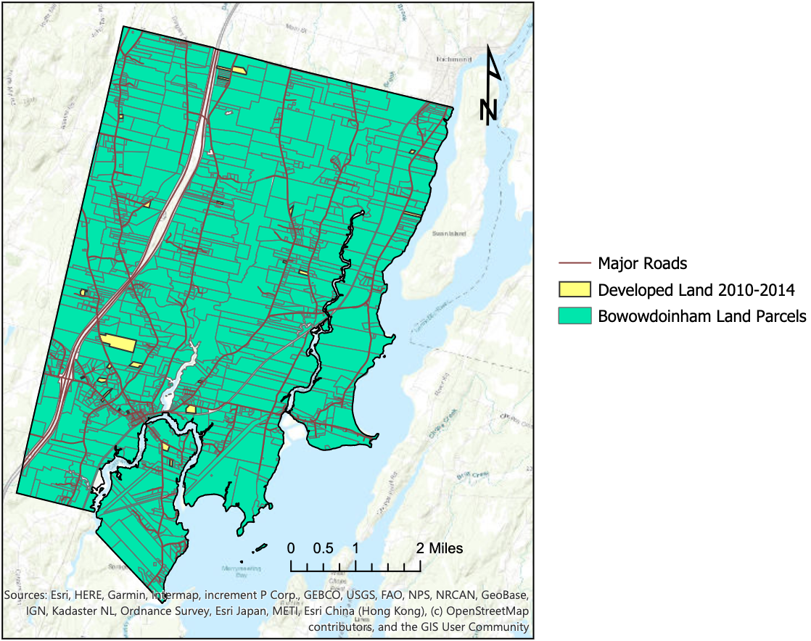
Fig 5: This map shows development in Bowdoinham from the years 2010-2014. As the legend suggests, major roads are highlighted in a dark brown, developed land is in yellow, and other parcels are in green.

2015-2019:
From 2015 to 2019, we see an increase in the number of parcels developed from 35 to 40. There seems to be equal development between the two Village Districts and in the Residential/Agricultural District.
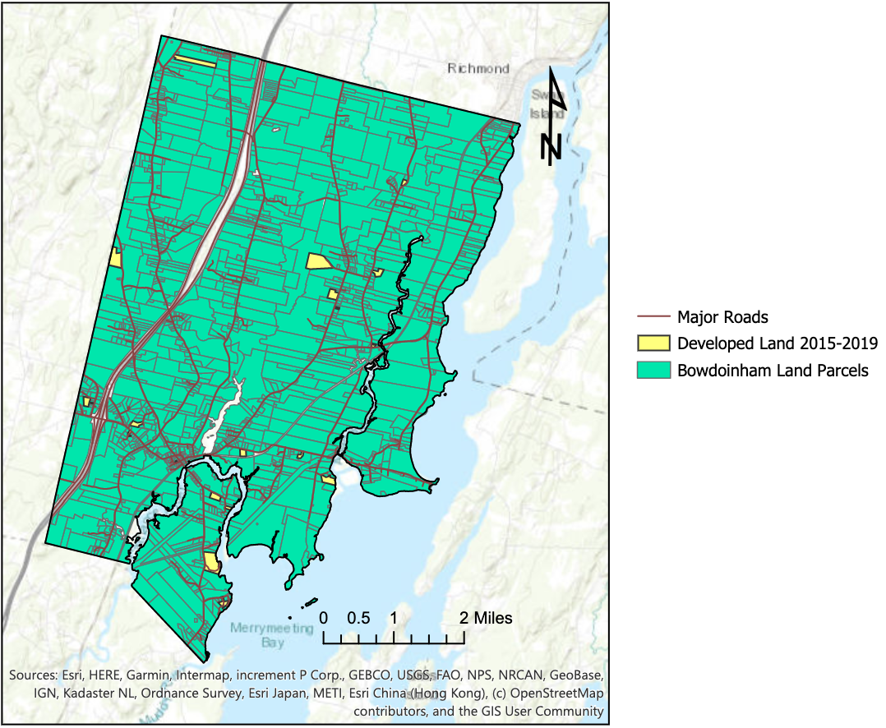
Fig 6: This map shows development in Bowdoinham from the years 2015-2019. As the legend suggests, major roads are highlighted in a dark brown, developed land is in yellow, and other parcels are in green.

2000-2019 and Development Type:
In the map below on the left, we see the parcels that have been developed over the past twenty years (272). This gives us a sense of the scale of development. The total area of land developed reaches 2119.44 acres (3.311625 miles) or approximately 8.45% of the land coverage of Bowdoinham has been developed. We see prominent development along Carding Machine Rd, White Rd, in the Village II district, all along Bay Rd and North into the Village I district, along Post Rd and Northward along Pratt Rd, and the North end of River Rd.
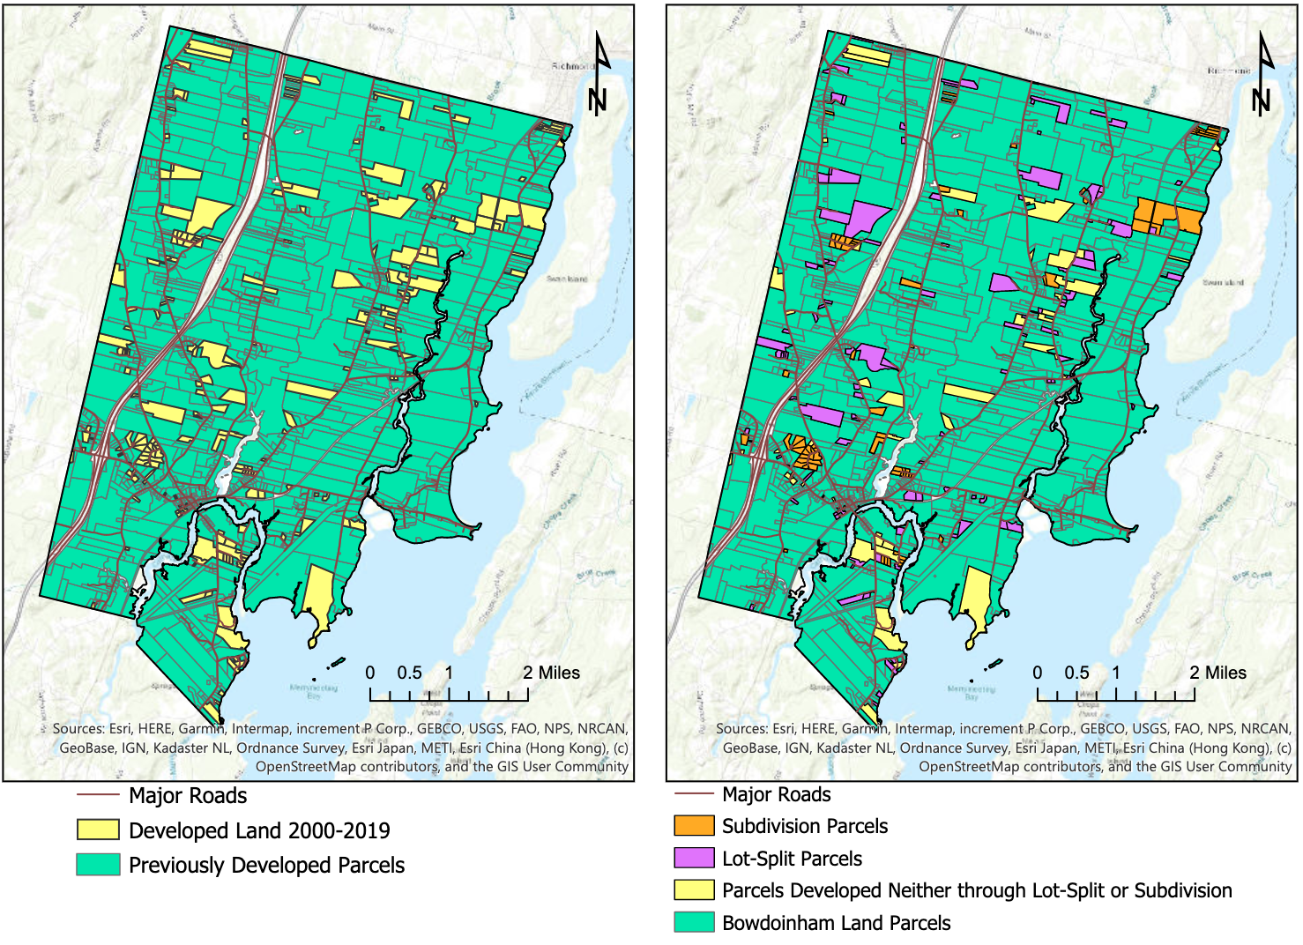
The map you see below on the right represents the distribution of parcels that were developed as a subdivision (Orange), lot-split (Purple), or undefined (Yellow) over the past 20 years. 216 of the 272 parcels developed were either lot-splits or new subdivisions. Of the 272 parcels, 138 or 50.735% comes from lot-splits, 78 or 28.676% comes from new subdivisions, and 56 or 20.588% is undefined development. As was stated in the 2014 comprehensive plan, the majority of subdivision development comes in groups such as the orange blocks we can see along River Road and Tegans Way.
Fig 7: These maps depict overall development in Bowdoinham from 200-2019 (left) and the types of development from 2000-2019 (right). On the left map, major roads can be seen in a dark brown, developed parcels can be seen in yellow, and other parcels are in green. On the right map, major roads are in dark brown, parcels developed via new subdivision are in orange, parcels developed via lot-split are in purple, undefined parcel development is in yellow, and all other parcels are in green. Subdivision development tends to be grouped in many parcels while lot-split development and undefined development occurs both in groups and alone.

Projections for the future:

The result of the model discussed in the methods section can be seen below. The parcels shown in a sea-foam green that either represent areas where we do not calculate a ranking from the parameterized model, or areas that cannot be developed because they are state owned public lands. The rest of the colors symbolize the likelihood of development on a scale from less likely (light blue) to very likely (deep blue). We see large "hot spots" of deep blue occur in 6 different places:

- Between fisher street, Main Street, and the Bowdoin town line
- Within the Village District I
- On the land to the east of Abbagadassett Rd, along Browns Point Rd, Centers Point Rd, and Northward until Pork Point Rd turns into River Rd
- Along River Road as it moves North toward Richmond
- Along Carding Machine Rd moving North of River Road, and also along White Rd North of Dinsmore Cross
- Along Ridge Rd as it nears Interstate 295

Additionally, we see many smaller clusters including the area along Bay Rd to the South of Bowdoinham and spots along the North end of Carding Machine Rd. While these smaller clusters may be outweighed by their larger counterparts, the potential for development anywhere where there is dark blue should not be dismissed.

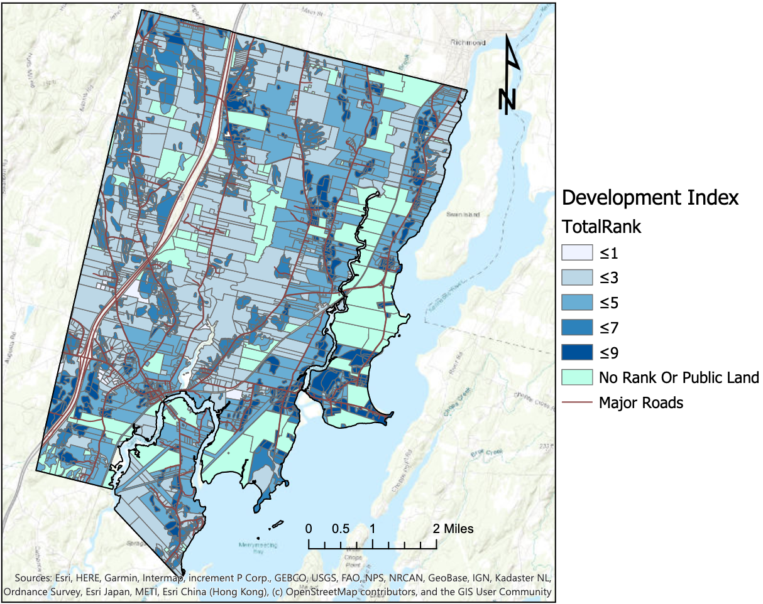
Fig 8: This map shows areas of Bowdoinham where we may expect to see future development. The likelihood of future development is represented by the variable “TotalRank” on a 1-9 in the legend. These rankings are based on the sum of the development model’s parameters for each section of land in Bowdoinham. The darker the color, the more likely we are to see future development. Areas that are in a sea-foam green either are parcels where we do not expect to see development or public land parcels.

Discussion:
While I believe that the research questions have thoroughly been answered throughout this project, there are a few areas of this assessment that could be improved on. Ideally, the model projecting future development would have included information such as the conditions of roads, bedrock data, WIFI connectivity, drainage, ease of transportation, and other factors that may affect the likelihood of development; however, putting together a comprehensive list of these factors would take much more time, communication, and human-power to complete. While my model is comprehensive and similar in complexity to the studies I have referenced in my methods section such as Ringo (2009) and Fagir (2016), there is still much more to be built on. I hope that my model is a building block from which a professional GIS consultant can begin to develop a more comprehensive model.
This project relied on accurate reporting of development from the Town of Bowdoinham and correctly defined parcel data. Unfortunately, because the parcel data is not as new as the development data, around 10 developed parcels do not show up on the map. One may expect that, for this reason, newly developed "map-lots" do not show up within the parcel data, but it seems that some subdivisions take the space of the whole prior parcel, and others are not represented at all. This makes the mix of missing data rather random over the past 20 years. This project encompassed a total of 272 instances of parcel development, meaning the highest percentage of error in map representation is 3.68% of all development. It is of my opinion that the slight misrepresentation of development data on our maps does not affect the information the maps provide. I aimed to show the location and timing of development in Bowdoinham over the past 20 years, and I achieved this with minimal error given the different ages of data. Nonetheless, this project should be repeated when the most recent parcel data for Bowdoinham is published in the future for even more accurate results.

Conclusion:
At the beginning of this analysis, I aimed to spatially represent development in Bowdoinham over the past 20 years. To do this, I mapped new development by joining a dataset from the Town of Bowdoinham with the most recent parcel data, and I classified each parcel developed beyond the year 2000 as either a lot-split, a new subdivision, or undefined. While there seemed to be no defining spatial trend to where new subdivisions, lot splits, or undefined development occurred in Bowdoinham besides new subdivisions often occurring in clusters, I can conclude that a significant chunk of development occurred outside of the lot-split or subdivision system. As I stated before, of the 272 parcels, 138 or 50.735% comes from lot-splits, 78 or 28.676% comes from new subdivisions, and 56 or 20.588% is undefined development. On the development side, we do see clusters of development within Bowdoinham. We see prominent development along Carding Machine Rd, White Rd, in the Village II district, all along Bay Rd and North into the Village I district, along Post Rd and Northward along Pratt Rd, and along the North end of River Rd. The total development in Bowdoinham in the past 20 years accounts for just under 8.5% of all land in the town. Within our model that predicts which areas of Bowdoinham may see future development, almost all of the developed parcels since the year 2000 fit within our prediction area. Our predictions for "hot spots" in development match especially well in the Village II district, along Bay Rd, along Carding Machine Rd, and the North end of River Rd. We can expect even more future development in these areas. Areas where we haven't seen lots of past development, but we may expect to see development in the future include:

- Along Pork Point Rd to the North of Browns Point Rd
- Further South of the Village II district along 295 and Booker Rd
- Along White Rd to the North of Dinsmore Cross
- Along Ridge Rd as it nears 295

While the above areas are prime areas for development within Bowdoinham, there may be reasons why we haven’t yet seen high levels of development here. On an individual level, one reason why we do not see development in these areas is that Bowdoinham’s controls for development could be too difficult for people to navigate if they want to split their lot (over 50% of development in Bowdoinham). On the industrial level, development companies may not target Bowdoinham as an ideal place to develop new subdivisions (only ~28.68% of development comes from new subdivisions). Further, low levels of development in these “hot spots” could be due to contention between property owners and conservationists; often quality farmland in Bowdoinham lies on the edge of “farmland of statewide importance” – land that must be designated to agriculture. Ideally, the Select Board, Bowdoinham’s committees, Town Manager, Town Planner, and Code Enforcement Officer, will discus how they want to either keep development levels the same, slow development down for both individuals and businesses, boost development levels for businesses and individuals, or make it easier for certain groups to develop within Bowdoinham. Successful programs to allow for ease of development includes Maine’s: homestead tax exemptions, renewable energy investment exemption, and BETR program among others. If commercial development is desired, land in ideal locations for business should be designated in TIF districts, and potential TIF subsidies to businesses from TIF accounts should be considered. It is important to, as Bowdoinham plans to adjust development bylaws, considers these predictions into consideration to both protect land from unwanted overdevelopment, and facilitate development in areas important to the economic and social success of Bowdoinham.

Bibliography:
Danesh, Ghazaleh, et al. "Compilation of a model for hazardous waste disposal site selection using GIS-based multi-purpose decision-making models." Environmental monitoring and assessment 191.2 (2019): 122.

DeBats, Donald A. "A tale of two cities: Using tax records to develop GIS files for mapping and understanding nineteenth-century US cities." Historical Methods: A Journal of Quantitative and Interdisciplinary History 41.1 (2008): 17-38.

Evenson, Bengte, et al. "Local variation in land use regulations [with Comments]." Brookings-Wharton Papers on Urban Affairs (2003): 221-260.

Fagir, Dalal Hassan Badawi. “Finding the Best Location for New Restaurant Using GIS Technologies.” Diss. Sudan University of Science and Technology, 2016.

Maine Department of Transportation. “MaineDOT Public Roads” [shapefile]. Maine Geolibrary, https://gis.maine.gov/arcgis/rest/services/dot/MaineDOT_OpenData/MapServer/52Description (2019).

Maine Office of GIS. “Maine Office of GIS Data Catalog: Parcels tiled by towns - Bowdoinham” [shapefile]. https://www.maine.gov/megis/catalog/parcels_tiles.shtml (2012).

Ringo, Linder G. "Utilizing GIS-Based Site Selection Analysis for Potential Customer Segmentation and Location Suitability Modeling to Determine a Suitable Location to Establish a Dunn Bros Coffee Franchise in the Twin Cities Metro, Minnesota." Papers in Resource Analysis (2009).

State of Maine. “Maine Conserved Lands” [shapefile]. Maine Geolibrary, https://geolibrary-maine.opendata.arcgis.com/datasets/maine-conserved-lands (2020).

The Town of Bowdoinham. “Comprehensive Plan – 2014.” http://www.bowdoinham.com/ town-document/comprehensive-plan (2014).

USDA. “Description of Soil Survey Geographic (SSURGO) Database ME606” [shapefile]. Version 20. USDA (2019).

USDA. “Soil Data Access (SDA) Prime and other Important Farmlands ME606”. https://www.nrcs.usda.gov/Internet/FSE_DOCUMENTS/nrcseprd1338623.html (2019).

