OPTION 1
1,100’ = Main St. from School St. intersection heading west, ending before driveway at 104 # Main St. (Reinheimer)
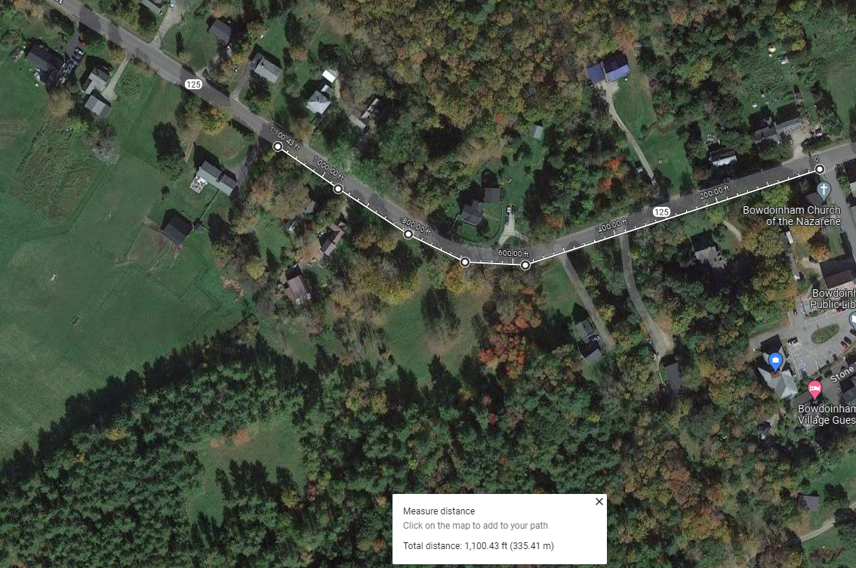
OPTION 3
1,510’ along Main St. from School St. intersection heading west, extending across entire frontage of 116 # Main St. (Kress)
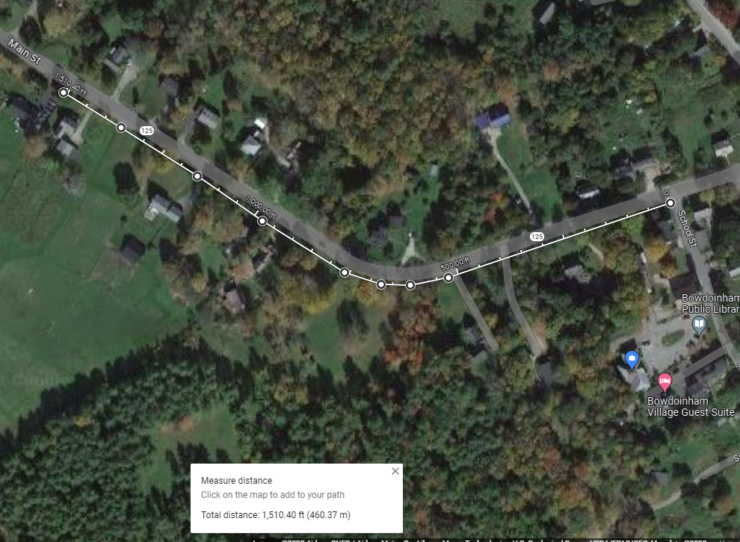

West on Main St. to: | Linear Feet | ROW | Utility Poles | Fire hydrants* | # driveways | Project Total | Grant Req | Out of pocket** | $/ft | Amt due 1/1/24 | Amt due 3/1/26
End before reaching driveway at 104 Main St. (Reinheimer) | 1,100 | 9 | 4 | 2 | 5 | $687,500 | $550,000 | $137,500 | $125 | $31,100 | $106,400
Extend across entire property frontage at 104 Main St. (Reinheimer) | 1,364 | 9 | 4 | 2 | 7 | $831,340 | $665,072 | $166,268 | $122 | $35,324 | $130,994
Extend across frontage at 116 Main St. (Kress) | 1,510 | 10 | 4 | 2 | 8 | $920,600 | $720,000 | $200,600 | $133 | $39,160 | $161,440
Notes
*Hydrant at church may not be an issue, other located a curve
**Does not include costs of maintenance Cost: employees, machine, sand/salt

Additional funding sources: Dog license fees, other grants, village walk-a-thon to raise money, 5k at Celebrate?

Crash data in project area from Maine DOT:
Occurance | Date | Time | Damage | Deer collision | ID #
1 | 1/23/2023 | 5:11 PM | Property damage only | Went off road | 2023-2235
2 | 2/13/2022 | 3:29 AM | Property damage only | Went off road | 2022-5060
3 | 1/13/2022 | 12:04 PM | Property damage only | Went off road | 2022-1068
4 | 11/8/2020 | 9:51 AM | Property damage only | Deer collision | 2020-27187
5 | 10/28/2020 | 2:02 AM | Property damage only | Deer collision | 2020-26489
6 | 3/24/2017 | 7:30 PM | Property damage only | Went off road | 2017-10028
7 | 2/10/2017 | 7:55 PM | Property damage only | Went off road | 2017-4945
8 | 3/16/2015 | 11:56 AM | Property damage only | Went off road | 2015-9647
9 | 7/30/2011 | 9:20 AM | Injury- non fatal | Head-on/Side swipe | 2011-22143
10 | 6/25/2011 | 1:34 AM | Fatal | Went off road | 2011-3701
11 | 2/5/2007 | 11:55 AM | Injury- non fatal | Went off road | 2007-3574C
12 | 1/26/2005 | 11:27 AM | Injury- non fatal | Went off road | 2005-3983C
13 | 1/5/2005 | 5:19 PM | Property damage only | Went off road | 2005-2513C
14 | 10/8/2004 | 7:30 AM | Injury- non fatal | Went off road | 2004-30277C
15 | 2/10/2004 | 10:15 AM | Injury- non fatal | Went off road | 2004-5102C
16 | 11/10/2003 | 4:03 AM | Property damage only | Deer collision | 2003-40153C
Source: mdotapps.maine.gov/mainecrashpublic/

