Goals & Recommendations

Land Use
Bowdoinham is a rural community on Merrymeeting Bay. Much of the landmass is highly forested and undeveloped, providing regionally significant habitat through its contiguous undeveloped blocks in Residential/Agricultural District and along Merrymeeting Bay and its tributaries. These areas provide much of the passive recreation, working/productive landscapes, and play a large role in climate mitigation and carbon sequestration. The Bay provides abundant fishing and hunting opportunities and supports high value agricultural soil. Village District I (VDI) is the most densely populated section of town centrally located on the banks of the Cathance River. Village District II flanks VDI to the west around the interstate and hosts some larger businesses and our two housing developments.

Goals

Be proactive in developing strategies to ensure residents can continue to afford to stay here, while protecting our ecological and agricultural resources, rural character, and making efficient use of public services.

Key Issues

How can we enhance the ability for property owners to develop their land in ways that keep taxes low, allow families to stay here, and prioritizes the conservation of natural and agricultural resources, while maintaining our rural character?

Recommendations

- Allow for smaller lot sizes, road frontage, and setbacks to encourage higher density development in the village districts.
- Expand Village District I to encompass all areas served by Bowdoinham Water District.
- Create a Village District III that encompasses areas that are or could be served by the Richmond Utilities District.
- Encourage alternative and cooperative wastewater treatment systems to support increased housing density.
- Continue to allow for mixed use development throughout Town with buffering between different uses.
- Explore strategies such as but limited to a Voluntary Municipal Farm Support Program, transfer of development rights, and easements which would allow for greater development densities in Village districts, while increasing preservation of high valued areas, such as agricultural soils, natural resources, and habitat in the Residential-Agricultural District.
- Limit division of large contiguous parcels of land in the Residential/Agricultural District through strategies like, but not limited to, increasing open space requirement for large subdivisions, reducing the density of new residential developments on large contiguous lots of land, directing new residential developments towards public roads by prohibiting residential back-lots, and setting a maximum lot size so new developments have smaller “footprints” while not restricting land-owners the ability to develop the same number of new lots.
- Minimize non-agricultural development on Prime Agricultural Soil, Farmland of Statewide Importance, or Farmland Soils of Local Importance.
- Protect active agricultural activities from new development by requiring buffers & setbacks.
- Minimize the impact of development in and around high valued areas, such as wetlands, waterbodies, and wildlife.
- Continue to encourage the preservation of open space, creation of greenspace, and access to land and water resources.
- Allow diverse housing types within the Town’s ordinances including cluster and co-housing.
- Support efforts to develop affordable, seasonal and workforce housing.
- Encourage the development of housing opportunities for the elderly and disabled, including supported living.
- Implement the Walkable Village Plan.
- Implement the Waterfront Plan.
- Continue to coordinate and partner with other municipalities, Friends of Merrymeeting Bay, and other organizations to protect natural resources.
- Continue to maintain and protect our critical natural resources through our Town, State and Federal regulations, including (but not limited to) Shoreland Zoning, Floodplain Management, Natural Resources Protection Act, Subdivision, Site Plan Review, Stormwater Management.
- Maintain, enact, or amend local ordinances as appropriate to:
  - Clearly define the desired scale, intensity, and location of future development.
  - Establish and maintain fair and efficient permitting procedures.
  - Explore streamlining permitting procedures in growth areas.
  - Clearly define protective measures for critical and important natural resources.
  - Ensure that the Town’s Land Use Ordinance is consistent with applicable State laws and rules regarding critical natural resources.
  - Review and update Shoreland Zoning rules.
- Assign responsibility for implementing the Future Land Use Plan to the appropriate committee(s), boards(s), or municipal official(s).
- Establish and support a housing sub-committee to recommend ways to increase housing in accordance with the comprehensive plan.

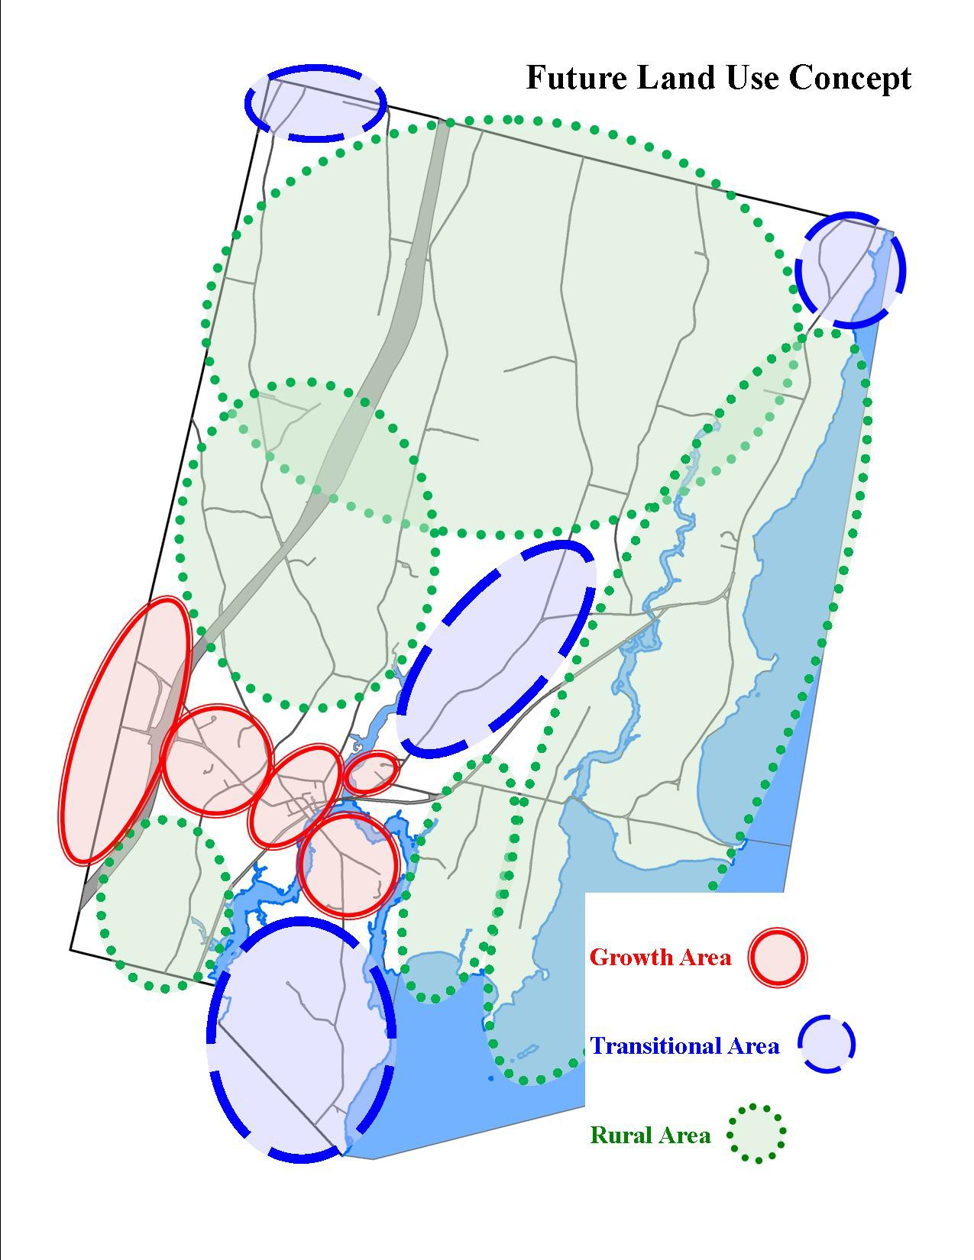
This to become Growth Area
This to become Rural Area

Growth Area

This Growth Area will allow the Town's historical village area to be maintained and grow into the surrounding developed area: Main Street to the highway interchange area and Pond Road, "Little Brooklyn" (the waterfront area to Wallentine Road), the area around the Bowdoinham Community School, Fisher Road where smaller lots currently exist, and the existing subdivision area around Browns Point Road. To allow for new development in the growth area, the required lot size will need to be reduced and residential density will need to be increased and provisions for cluster subdivisions and multi-family developments should be considered. The existing lots in the historic village area are 10,000 to 20,000 square feet. To keep in character with our historic village area, mixed-use development (residential, agricultural, commercial, institutional, and industrial) should be allowed to continue. The Town's current Site Plan rules were created in 2008 to address mixed-use development through-out Town and should be adequate as mixed-use is allowed to continue. However, due to the Shoreland Zone and Floodplain areas within this growth area, some industrial and commercial uses will have to continue to be restricted. As the village area develops, the Town will need to continue with its capital investments (sidewalks, three phase power, public utilities, and other amenities) as planned.

Transitional Area

The Transitional Areas are the areas in Town which are located adjacent to more developed areas (Richmond's village, highway-interchange areas, Topsham's Rural Residential District) and our growth area. While these areas may be appropriate for development, the Town wants to direct its growth and the capital investments to support growth into the growth area. These transitional areas should continue to allow mixed-use development (residential, agricultural, commercial, institutional, and industrial) in accordance with the Town's Site Plan Review rules. Additional regulations will impact development in the transitional areas that are within the Shoreland Zone and Floodplain areas.

Rural Area

The Rural Area includes most of the Town's agricultural land, forests, natural resources (wetlands, wildlife habitats etc.), and preserved lands. The ability of the land to support new development varies through-out this Rural Area. Bowdoinham is known for both its poor soils (wet and clay) and good agricultural soils. The minimum lot size and residential density should remain one-acre on smaller lots, while the subdivision of large contiguous parcels should be limited by lower residential density requirements and a significant open space requirement for major subdivisions. Consider increasing the required road frontage for new lots. While home-based businesses, residential and agricultural uses should continue to be allowed, the Town should consider restricting commercial and industrial uses that would negatively impact the existing uses and important natural resources. Additionally, the Town should take steps to protect and maintain its agricultural activities and agricultural soils.

Critical Natural Resources

Our critical natural resources should continue to be maintained and protected through our Town, State and Federal regulations, including but not limited to, Shoreland Zoning, Floodplain Management, Natural Resources Protection Act, Subdivision, Site Plan Review, Stormwater Management. Please refer to the following maps:
- Bowdoinham Habitat and Marines Resources
- Beginning with Habitat - High Value Plant & Animal Habitats
- Regionally Significant Habitats and Undeveloped Blocks
- Water Resources
- Bowdoinham Shoreland Zoning Map
- Bowdoinham Floodplain Map

