Post-Event Community Survey

Staff solicit the public to join a Celebrate planning meeting each spring though the newsletter, Facebook posts, and the town website with little response. This year we shared an online survey with the public in hopes of generating more ideas and gathering feedback we would not get through our typical outreach. It was shared on Facebook, our e-newsletter, and on the website. From September 15- October 7, we heard from 24 respondents, three were interested in helping next year. Here is a summary of the information we received.

Is this your first time attending this event?
All 24 respondents indicated that this was not their first time attending, suggesting a strong base of returning community members and consistent interest in the event.
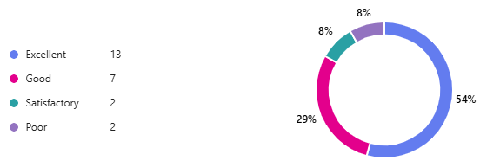
Overall, how would you rate this event?

This reflects a largely positive experience, with over 62% rating it as excellent.

What did you like most about the event?

Highlights included:
- Community spirit: “Getting together with people,” “Community feel,” “Seeing lots of people I haven’t seen in a while.”
- Parade: Frequently mentioned as a favorite, with comments like “The parade!! It was incredible this year.”
- Fireworks: A consistent favorite across responses.
- Lobster crate races: Mentioned multiple times as a standout activity.
- Kid-friendly atmosphere: “Great kid activities,” “Family friendly,” “Zucchini races.”
- Traditions: “Same traditions we always look forward to year after year.”

What changes would you make to improve this event in the future:

Suggestions included:
- More variety: “More food vendors,” “Vegetarian options,” “Add ice cream.” “Same food vendors each year” “Info on educational supports and addiction/mental health topics” “Higher quality craft vendors and more of them”
- Better signage and communication: “Large sandwich boards with schedule/map,” “Clarity on parking.” “More recycling opportunities”
- Expanded activities: “More parade floats, bring back town financial support for non-profits to make floats” “More stuff for kids,” “More community booths,” “Farmer’s Market options.” “Spread out of events left dead time” “Longer hours for vendors and waterfront events” “Keep people engaged during dinner time” “Mayve a few rides for the younger kiddos.”
- Parking concerns: Several noted issues with lack of parking near the waterfront park and needing more communication on alternative parking.
- Music: “Better music/bands,” “Digital music when live bands aren’t on stage.”
- Face painting: “Wait was nuts,” “More than one face painter.”

Planning for next year do you have any suggestions for a parade theme, or any new activities you would like to see included?

Ideas included:
- New activities: “Kayak demo,” “Water tours,” “Canoe/kayak race,” “Paddle boarding lesson,” “Balloon pop wall,”;“Ring toss games.”
- Agricultural fair vibe: “Lean into farming aspect of Bowdoinham’s culture,” “Expand baking contest to include pickle and jam categories.”

Additional feedback.
- “Interested in hearing what volunteer opportunities are available.”
- “I would love to see the baking contest be even bigger.”

How would you rate each of these activities/elements?

