SOP – Bowdoinham Business Directory
Last updated: 5/21/2022

Purpose
This document defines the Bowdoinham Business Directory and the processes required to maintain the directory.

Scope
This SOP applies to anyone who performs business directory maintenance.
The Business Directory is a database of businesses primarily located within the Town of Bowdoinham. The directory is part of the Town of Bowdoinham website.

Business Directory Definition
The Bowdoinham Business Directory is a directory of local businesses located primarily in Bowdoinham. It is maintained in a relational database that is accessed via the town web pages, which also provide the mechanism for creating, editing and deleting business entries. The structure of the town website is out of the scope of this document. Access to the database is via the drop-down menu items under Local Businesses. Refer to the section Navigation maintenance for details.

Content Policies
1. Accuracy – Information in business listings must be accurate.
Links to web sites must operate and the website must adhere to the legal and language requirements, below.
2. Legal – Content must not infringe copyright or trademark. The business must engage in a legal business. If required, trade licenses and insurance must be maintained by the owner.
3. Language – Business entries are primarily English but may have incidental non-English phrases or symbols. Abusive or inflammatory language is prohibited.
4. Required for business entries are a business name, a description of the business and logo art or picture.
Four required fields of contact information on the request form are Your Name, Your email, Your mailing address and Your telephone but these fields are not stored in the database. It is expected that the business directory directory maintenance person will maintain the contact information in a separate repository.
(The original input form did not require this)
5. Logo artwork or business picture must be JPG or PNG format. Maximum size 2MB.
6. Entries to the directory require the business be located within Bowdoinham town limits or have one or more principal owners reside in Bowdoinham.

Adding a business
The business owner submits the initial entry using the input form in the town website. The maintenance person checks the submission, checking spelling and grammar, making corrections as required, then creates the listing using the Add Content → Business Directory Listing function and transferring all appropriate data from the submission to the actual listing. The maintenance person copies the required four fields of contact information to an external storage. The maintenance person shall email a link to the final entry (the URL) that is posted in the town website to the business owner or designated contact.

Modifying a Business
The business owner submits an entry form with the new information. Since this business is already in the database, the input form is interpreted as an update. As with Adding a Business the maintenance person shall email a link to the final entry (the URL) that is posted to the town website to the business owner or designated contact.

Removing a business
During a periodic verification, if a business is determined to no longer be in operation it must be removed. The content of removed businesses shall be maintained in a separate archive for historical reasons. If all avenues to contact the owner (phone, email or website) fail, the business is considered non-operational and must be removed.

Editing a business
1. Requested by the business owner. (Via email or the Business input form most generally)
2. Changes detected during a periodic verification.

Enter the Edit mode, make the changes and Save the document.

After editing, send a link to the edited entry (the URL) to the business owner via email so the edit can be reviewed for accuracy. Ensure the owner is sent the link after every edit session for final review.

No further authorization is required beside the interaction between the maintenance person and the business owner. Courtesy notification of the changes may be provided to other personnel as requested.

Periodic Verification Process
Periodic updates are handled in batch mode or distributed mode. Batch mode means to update the entire directory at one time, annually or some other period. The distributed mode means to update the directory a small percentage more often so the whole directory is updated on the same cycle as the batch mode.

For example, a distributed mode entails each month: verify approximately 10% of the database by contacting the owner, using email, phone or optionally regular mail, asking if there are any changes that the owner would like reflected in the listing. Verification of address can be done using the town tax records for Bowdoinham property owners, as well.

Using email is preferred because it provides a documentation trail of the contact.

Verification includes all items in the listing. Ensure the referenced website is operational and reflects the business.

Once the business owner has been contacted, wait several days, up to two weeks. If there has been no response, repeat the contact two more times. Alternative forms of contact such as a phone call or paper mail may be used. If the owner does not respond after three attempts, archive the listing and delete it from the active directory. <<it may be advisable and polite to send a written notice to the owner>>

Update tracking
The tracking process of updating the business database is left to the maintenance person.
There is a report that may be used to provide an initial starting point. Under the Handbook tab in the Admin menu, executing the Business Directory Export produces a comma separated values (CSV file) spreadsheet that contains all the businesses in the directory and several fields from each business., one row per business.

Unsolicited updates
Users of the web site may report discrepancies. These are verified by the maintenance person as received and implemented in a timely manner. Users may report that a business is no longer operational. Once this is verified, the listing must be removed.

Navigation maintenance
As the business directory grows or shrinks, the browsing and the searching mechanisms may require enhancement.

Selections to the Business Directory in the Town web site:
Top drop-down: Local Business

Drop-downs under Local Business:
Browse Local
Businesses

Search Local
Businesses

Add Your Business
Listing

Browse Local Businesses
Provides a scrolled alphabetical listing of all businesses or a listing of each initial letter of the business name. Selecting a letter in the drop-down filter list results in the list being restricted to businesses whose initial letter of their business name matches the selected letter. Selecting “Any” provides a list of all businesses in the directory.

Search Local Businesses
Provides a search by key word or by business category. A successful search results in a scrollable list of businesses meeting the search criteria.

Categories
The following is a full list of currently used categories:
Accounting and Business Services
Arts, Crafts, Design and Photography
Automobile Sales, Maintenance and Repair
Banking and Financial Services
Child Care
Construction, Repair and Improvements
Education and Training
Equestrian Services and Supplies
Forestry, Tree Services and Firewood
Fuel Oil, Gas and Coal
Gardening Supplies, Farming Supplies and Plants
Health, Beauty and Salon
Home Decor
Hospitality, Hotels, B&B and Guest Suites
Hunting and Fishing
Insurance
Internet, Websites and Information Technology
Lawn Services, Snowplowing
Legal Services
Machine Shop and Metal Working
Meat and Produce
Medical Services and Supplies
Music, Musicians and Musical Instruments
Performing Arts
Plumbing, Electrical and HVAC
Real Estate Sales, Rental and Leasing
Restaurants and Food Services
Small Engine Repair
Sports and Recreation
Surveying, Engineering Services and Permitting
Veterinarian Services and Supplies
Woodworking, Cabinetry and Furniture Repair and Restoration
Writing, Journalism and Editing

Add Your Business Listing
Provides an input form to enter a new listing.
The Business Name, Business Description and Business Logo (or other artwork) are required fields. The remaining fields are optional. If the user does not include either an email address, a phone number or a website with contact information the listing would not be very useful. Fortunately, the vast majority of submissions have included both phone numbers and website links.
Contact information is required but is not published to the website nor maintained in the town database. These four fields are to be maintained externally. Your Name, Your email, Your mailing address and Your telephone.
Once the input form has been submitted, the maintenance person reviews it, makes minor spelling and grammatical corrections, creates the business listing using the Add Content → Business Directory Listing function and sends a link to the entry for the owner to review. Ensure at least one form of electronic communication is included: phone number, email address or website (if the website includes at least an email address, a phone number or input query form).

Screen Shots
These screen shots are shown in logged in mode with editing and shortcuts enabled.

Browse Local Business

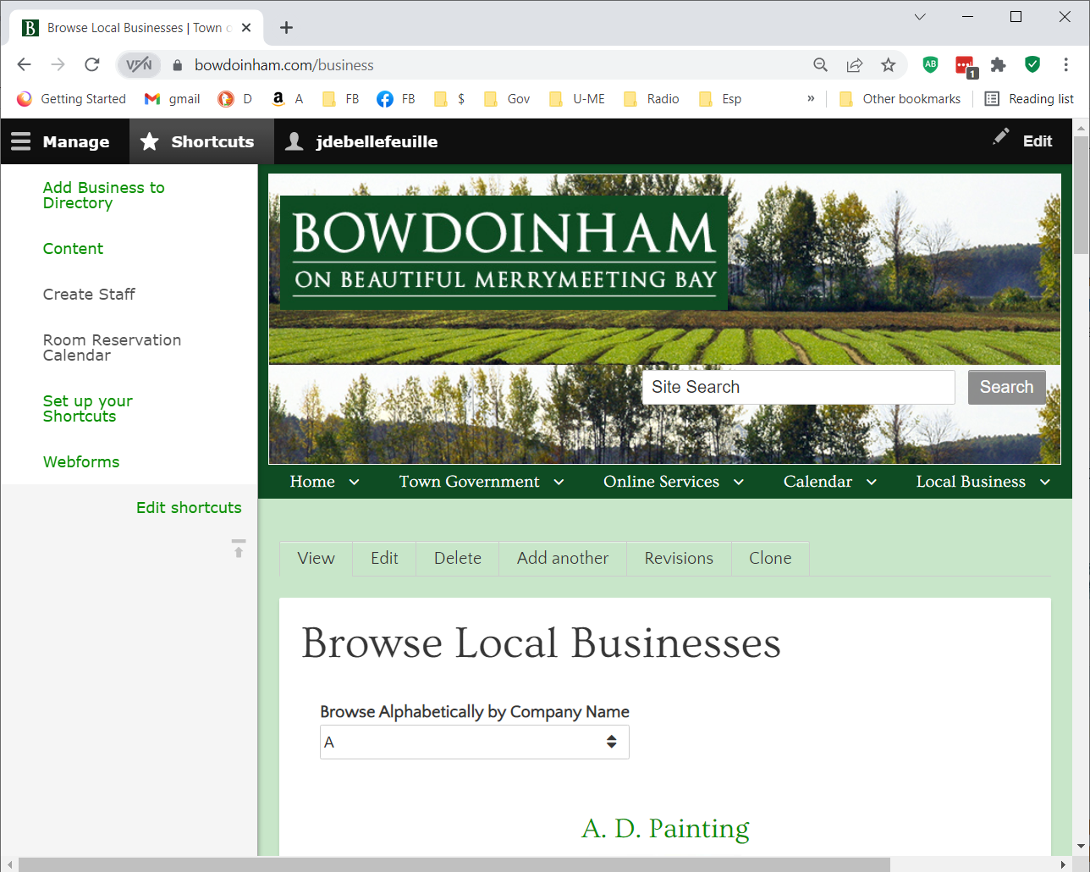Functions
View – Read only the contents of the business data.
Edit – Enter edit mode and make changes to the content.
Delete – Remove the listing in its entirety. If executed, the data is permanently removed and cannot be retrieved.
Add another – Enter data entry mode to enter another business. It shows the same fields as in the edit mode except all the fields start empty.
Revisions – Display all revisions for this business and revert to a previous revision if desired.
Clone – Make a copy of this business listing.

Edit example

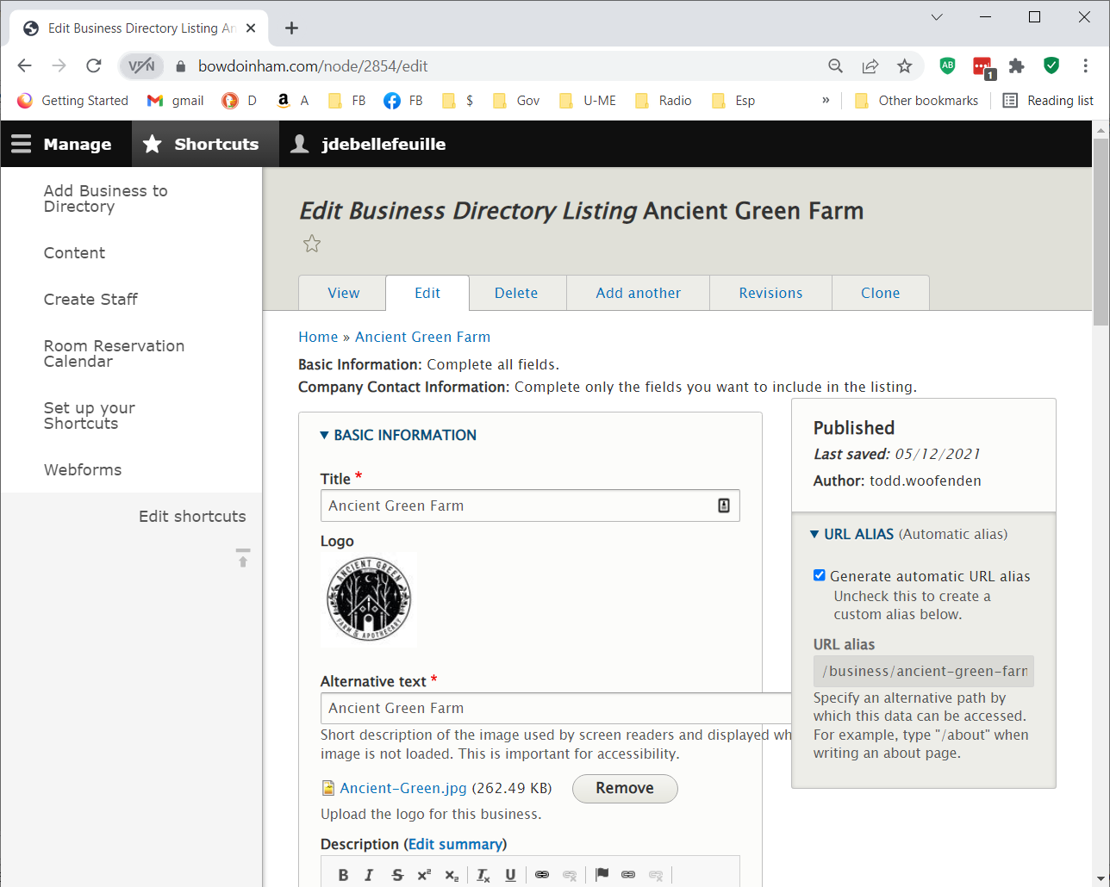

Revisions example
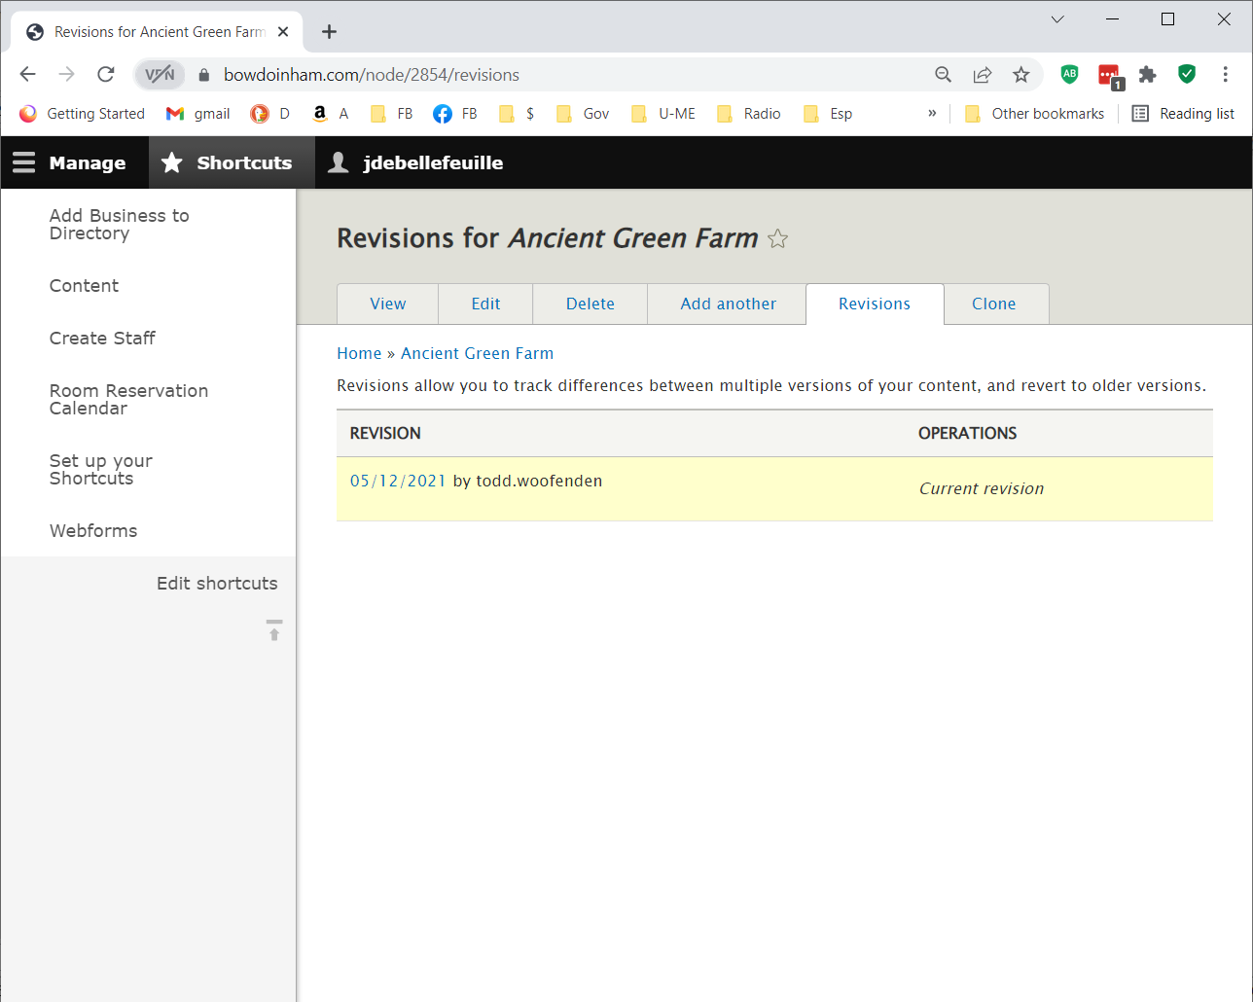

Creating New Business example
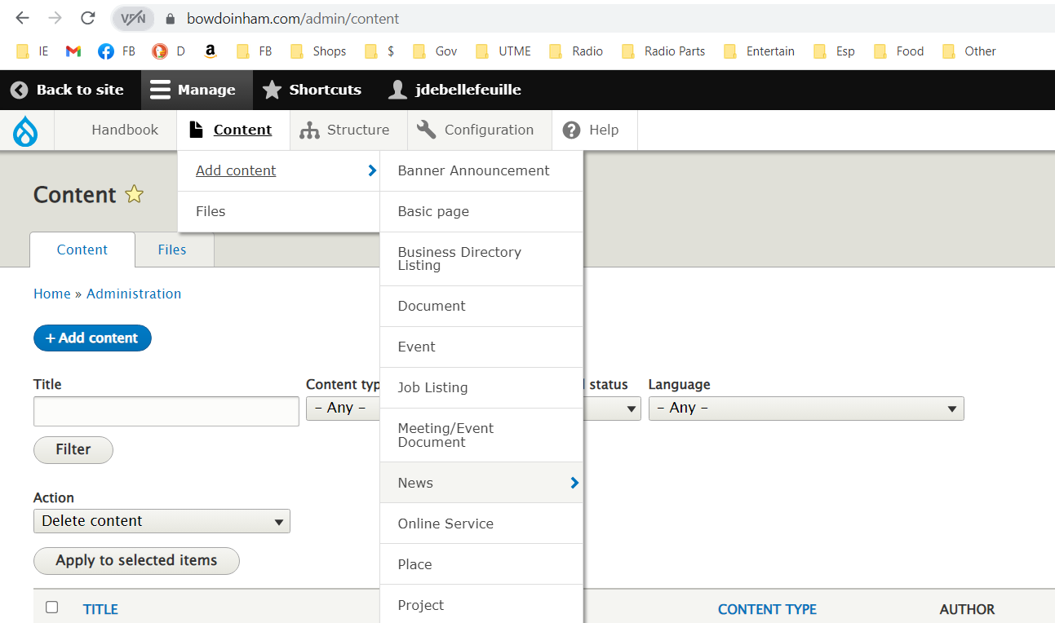

Admin Menu → Content → Add content → Business Directory Listing
This bring up an input form to create a new business listing. The maintenance person transcribes (copy & paste) from the business submission to this to publish to the web site.

