CDAC – Leveraging town website to promote business locating in Bowdoinham
Updated – 2/8/2023

This document is a work in progress of ideas to use the website vs. brochures or other printed matter

Basic assumptions
Bowdoinham would benefit by having a wider variety of business in town
Updating the website periodically is more flexible than producing and distributing printed matter
Most people are computer and internet literate

On the town website, introduce the following:
Under Local Business
Add entry to Moving/Starting a Business in Bowdoinham
Bowdoinham advantages
Location
Proximity to I-295
Directly on Rte 24
Central intersection is Rte 24 and Rte 125
Between Topsham and Richmond
Easy access to Bowdoin, Litchfield, Brunswick, Gardiner
Five County Credit Union virtual branch
Access to Cathance River
Boat launch to Cathance River
Canoe and Kayak storage rentals

Property available on Main St and other locations
Tax incentives for these businesses
Bakery
Cafe – Breakfast, primarily
Retail – sundry gifts and craft items
Light Manufacturing
Call center
Retail – clothing sales

Village area is walkable, (sidewalks)
Relatively small area
Broadband available
Three phase electricity available
DSL phone available
Town water available in central Bowdoinham
Mailly Waterfront Park (Cathance River)
Skate Park
Curb side trash pick up
Outstanding Public Works Department
Fire Department
Weekly Farmer’s Market – Saturdays, June ~ October

Bowdoinham Businesses Profile, largest categories
Construction, Repair and Improvements
Arts, Crafts and Design
Groceries, Meat, and Produce

On the town website, relocate the following:
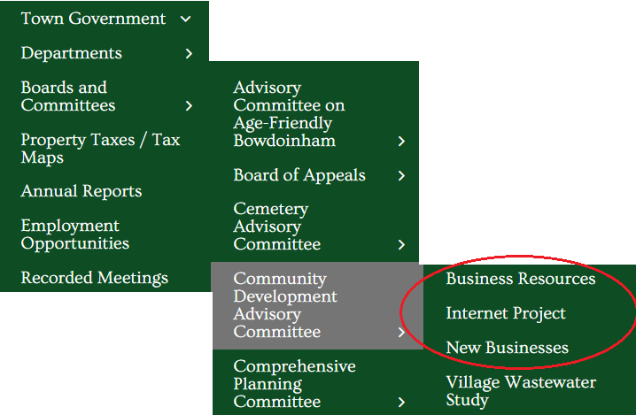 List up to three years of completed projects and a list of projects in progress. Update quarterly or semi-annually.

Move the three circled topics to be under Local Business:

As follows:
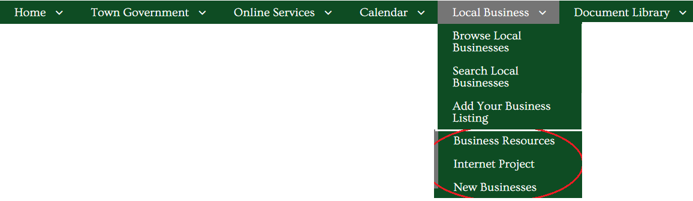

Business Resources
Review and update underlying document.

Internet Project
Update this to represent all internet availability in Bowdoinham.

New Businesses
We are so glad you have decided to operate your business here in Bowdoinham. There are a lot of resources that may be helpful to you as you move forward with your business activity:
- Business Resources – this is the same as Business Resources, above.
- Starting a New Business
- Business Start-up Checklist
- Get listed on the Town's Business Directory – This is the same as Add Your Business Listing
- Business Permitting and Licensing
One of our Town committees, the Community Development Advisory Committee, focuses on projects intended to support the economic activity in town. Members of that committee would be happy to visit with you. They will orient you to the services that are available and talk with you about your business goals. Please let the staff at the Town Office know if you would like to have them call on you.

